FORMPAK INC

The IOM covers the following:
- 2100 ST
- 2100 SS
- 2100 SS IS
- 2100 SS PS
- 2100 SS DD
- 2100 SS MB

2100 SS Series IOM
2021 eDITION

DISCLAIMERS:

NOT ALL ITEMS IN THIS MANUAL ARE ON EVERY SYSTEM.

SYSTEM CONFIGURATIONS VARY PER CUSTOMER ORDERS & SPECS.

ANY MODIFICATIONS TO THE EQUIPMENT WITHOUT APPROVAL OF FORMPAK ENGINEERING WILL RESULT IN VOIDING ANY WARRANTY.

Operation Hours

Monday – Friday 8:00AM-5:00PM CST

Contacts at FormPak

Mike Owens Ext 402
Sales / General Questions
Email: mike@formpakinc.com

Larry Markos, P.E. Ext 403
Engineering / Technical Support / Maintenance
Email: larry@formpakinc.com

Robert Contreras Ext 405 Operations Manager Email:
Email: robert@formpakinc.com

Joseph Beckerman Ext 414
Electrical / Controls Email:
Email: josephb@formpakinc.com

Brian Beirne Ext 412
Purchasing / Parts Email:
Email: brianb@formpakinc.com

Fax: 314-475-3201

INDEX
Section Page
- Introduction 4
- Pre-inspection/Unit Arrival 5
- Hardware list 5
- Unpacking Instructions 5
- Installation 6-15
- General Assembly 6-9
- Scale Controller 920i 10-15
- Operation 16-20
- Maintenance 20-25
- Gyrator Force Adjustment 20-23
- Gyrator Force Adjustment 24-25
- Replacement Parts List 26
- Optional Enhancements 27-30
- Formpak Machinery Catalog 31

- Introduction
Our heavy-duty bulk bag fillers will exceed your requirements for safe and reliable Super Sack® (bulk bag, big bag, FIBC) filling. Our basic bulk bag filling machine is designed to fill duffel or open top bags to volume. Add FormPak’s Fill Head/Seal and scale controller and you have an accurate gravimetric filling system that is dust-tight and automated to fill by weight.

- Our bulk bag filling machines utilize heavy structural steel frames, adjustable holder arms for multiple big bag heights, and fork lift pockets for mobility.
- Our Fill Head features a two piece design for dust tight connections to the Super Sack®, while providing an efficient dust collection port.
- Our top of the line scale controlled filler, fills bags to precise weights with bulk and dribble flow settings.
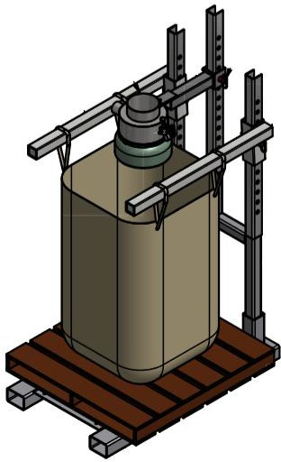
II. Unit Arrival
- Hardware list
- Frame base
- Frame upright
- Bag holder arms (2)
- Mounting bolts (4)
- Arms hitch pins (2)
- Fill Head
- Inflation Seal
- Clamps (2)
- Valve Regulator Gauge Assembly
- Rice Lake 920i Controller (Optional)
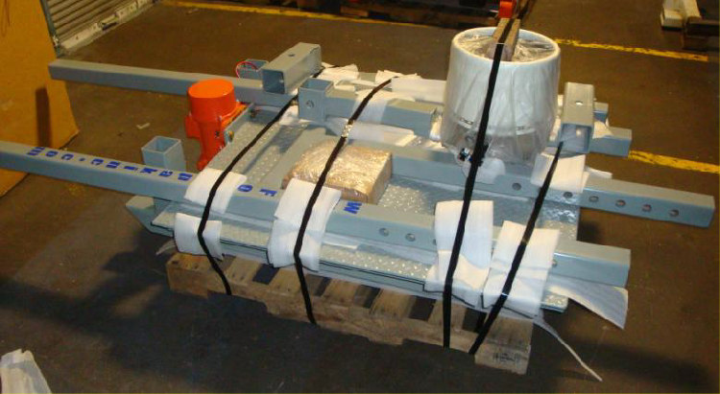
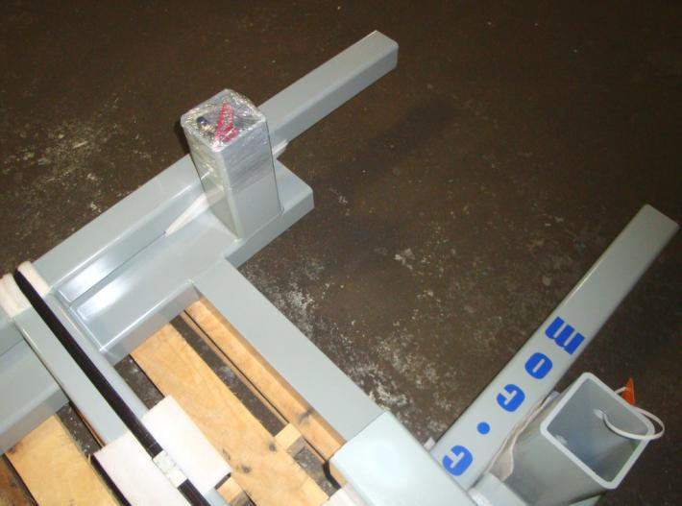
- Unpacking Instructions

The frame upright securing bolts and the bag holder arms hitch pins are located inside one of the frame base upright post holes (as shown below) or in a box of hardware attached to your shipment. Carefully cut and un-strap the unit from the skid for assembly. Remove the bolts and hitch pins from the upright post hole (do not discard).and un-strap the unit from the skid for assembly. Remove the bolts and hitch pins from the upright post hole (do not discard).

The BagPak 2100-SS unit comes packaged as shown.

III. Installation

FOR SAFETY, it is best to have at least 2 qualified people working on the assembly of this unit.
National, state, and local safety codes must be adhered to.

Failure to follow the steps could result in injury or death.

For reference of Assembly please watch these videos

Initial Installation: https://youtu.be/ufh-I_ED4nc

General Overview: https://youtu.be/WAkk6zRp5iY
- Place the frame base on a flat surface, slide the upright section into the frame base post holes and thread (4) securing bolts into the threaded extensions (see Figure 2).
- Firmly and securely tighten the mounting bolts to hold the frame upright in place. These bolts should be checked regularly (and re-tightened if needed) to maintain unit stability and safety.
- Once the frame upright is secure, the bag holder arms can be added to the unit. Position the bag holder arm to the outside of the frame upright as the sleeve slides over the upright post. Then place a hitch pin through the alignment positioning holes of both items. Repeat for the other arm.
- Next, position the fill head arm assembly on the center upright post, place a hitch pin through the alignment positioning holes to hold it in place until the proper height for your bag height is established. Do not tighten the adjustment bolt until the bag height is final.
- The final bag holder arm height position is determined by your bag height. Place a skid onto the frame base and hang an empty bag on the holder arms. The holder arms should then be adjusted to a height that allows for the pallet on the base, the bag hung by the loops a leaves 2” – 3” of clearance on the corners of the bag above the pallet. This will allow proper filling of the bag (See Figure 3).
- The pre-assembled fill head and arm assembly height should be adjusted so that it is just above the bag holder arm height, typically 2”-4” above top of holder arms.
The Air Inflation System (valve, regulator & gauge) will have a 1/4” female threaded end for a compressed air connection, which is used to inflate the gum rubber bladder of the fill head assembly into the bag spout for the filling operation. To adjust this inflation boot, turn the regulator until there is no air pressure. Pull a bag spout up and onto the boot. Slowly turn the regulator up, until the air bladder is snug inside the bag spout. This will be about 3-5 psi.
- Insert the hitch pins safety pins to capture and hold the hitch pin in place during operation
III. Installation (Cont.)
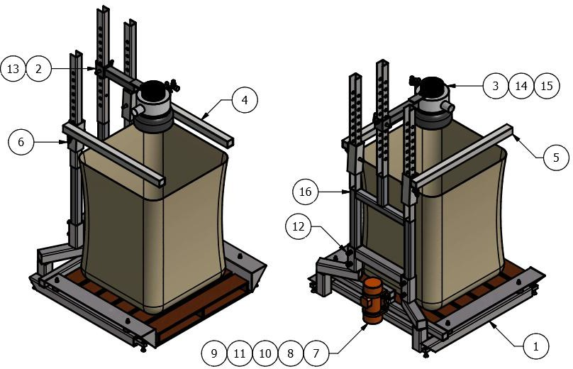
1. Low Head Lower Frame.
2 Support, Fill Head.
3. Standard Fill Head, 4” Dust Port. 4. Left Side arm.
5. Right Side arm. 6. Hitchpin with hairpin Clip.
7. Gyrator motor. 16. Upper Frame.

FINAL SAFETY STEP PRIOR TO ANY ACTUAL BAG FILLING OPERATION

The hitch pins safety pin MUST be inserted to capture and hold the hitch pin in place during operation.

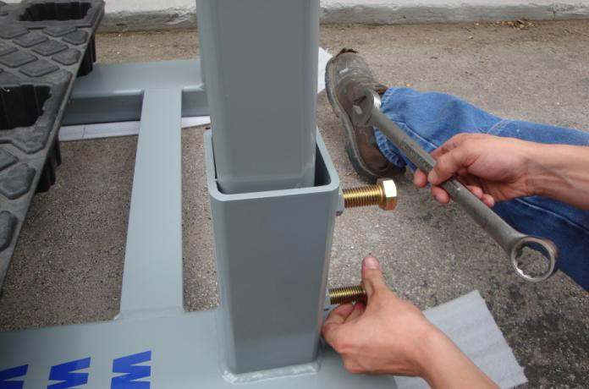
III. Installation (Cont.)
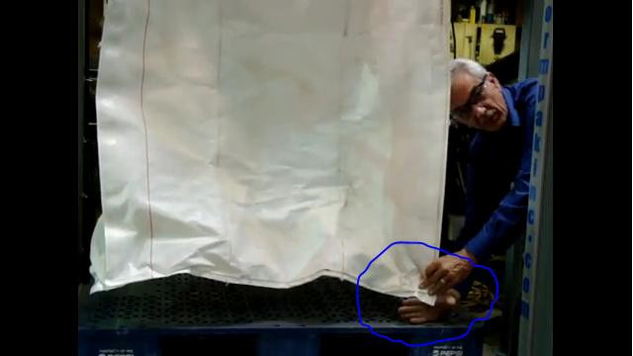
(Figure 2)
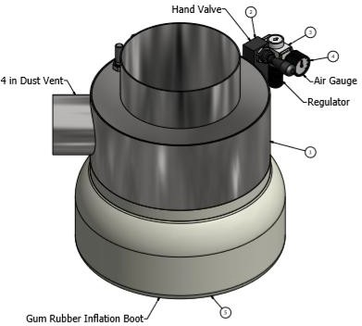
(Figure 3: Setting the fill head height)
(Figure 4)

III. Installation (Cont.)

Calibration of your BagPak-2100-SS Controller – Scale

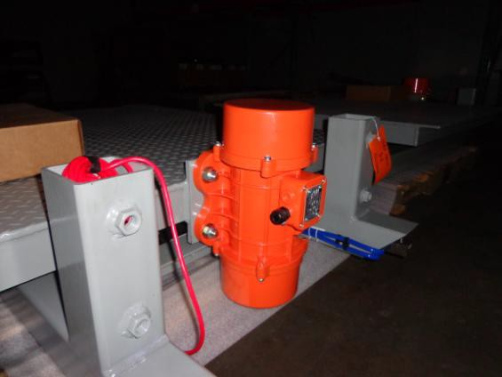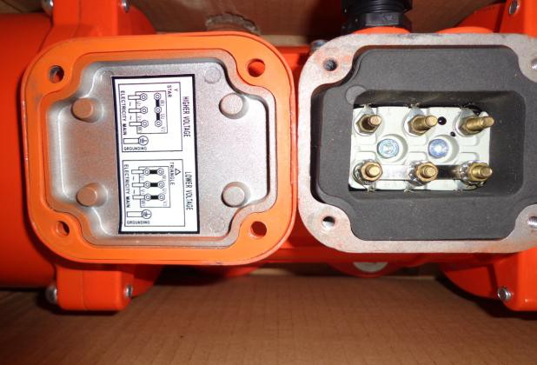
(Figure 7)
- Press these two buttons to enter the set up mode (See Figure 11).
- Press #3 then the enter button to select "CALIBRATE SCALE 1" (see Figure 12). 3. Press the enter key for CAL 1 = 0 (See Figure 13).

Be sure no weight is on the scales.

4. You will see CALIBRATING… as the controller calibrates the first set point (See Figure 14). 5. When the screen in Figure 15 appears, place the known weight on the scale then enter the
weight using the key pad. In this case, the weight was 500 lbs. 6. Once the correct weight is entered, press the red enter button.
7. You will again see CALIBRATING… while the controller calibrates Cal 2 (Figure 14). 8. Remove the weight from the scale, when this screen in Figure 16 appears.
- Once the weight is removed, press the red enter button.
- When the screen in Figure 17 appears, calibration is complete, but you must exit the calibration program, by pressing the up arrows several times.
- Calibration is being saved (Figure 18).

III. Installation (Cont.)

Assembly of your BagPak-2100-SS Controller – Scale

- The controller is either in a small enclosure from the manufacturer’s factory (figure 5) – or face mounted in a control panel (typical if there is densification on the unit). This is shipped loose for mounting near the filling station (Figure 6).
- Once mounted, power will need to be supplied to the unit by an electrician. In some cases this will be simply 110v for the scale controller only. In other cases, this will require 3 phase power. If a separate control panel is supplied, the wiring diagram will be inside the enclosure. There is a scale control wire that can be seen on the rear of the machine (the summing box). In some cases this will have a pig tail attached to it – that simply plugs into a mating plug on the control panel. In other cases these wires will be unattached and will need to be pulled into the scale controller and connected to the terminals as indicated in the photos on the next page or in the scale controller manual provided by the manufacturer.

Never attempt to connect three phase power unless you are a qualified electrician.

- {Optional} If your unit was delivered with a vibratory (gyrator) densifier, an electrician will need to pull 3 phase wire from the leads on the gyrator motor, to the control box and into the requisite connections on the motor starter (see Figure 10).
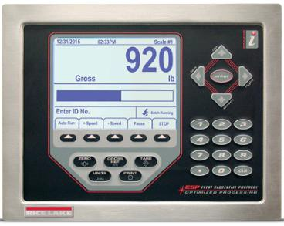
- Be sure gyrator is wired for 460 or 230, depending on your system. Call us if you are unsure.
(Figure 5)
III. Installation (Cont.)
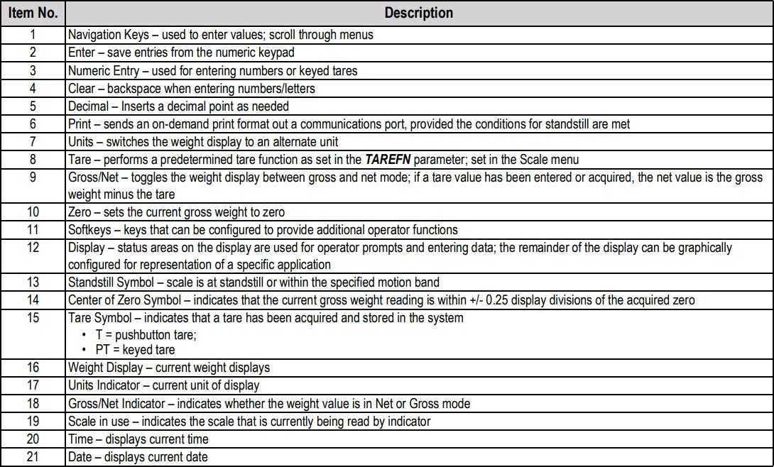
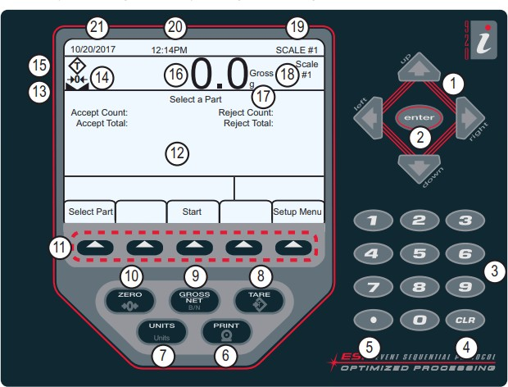

III. Installation (Cont.)

Programming of your BagPak-2100-SS Controller – Scale
The scale controller is the heart of the filling machine. It provides the relay functions to operate the inlet valve or conveyor, the fill head seal release, the eject mechanism once the bulk bag is filled and timing for the settling vibrator, depending on options.

1. Before filling a bulk bag, the scale must be set up. 2. To begin scale set up, press the "PRESET" key.
- Once pressed, the PRESET key will show the screen in Figure 19. 4. The functions set on this screen are …
  - The weight to start and run time for 4 vibration cycles,
  - The FILL weight (desired weight in filled bag) and the TRIM.
- To change any of the values on this screen, enter the line number then press the enter key.
- In the Figure 20 example, the vibrator starts running when the weight in the bag attains 500 lbs and it runs for 1 second. When the weight attains 1000 lbs, it runs for 2 seconds. When it attains 1500 lbs, it runs for 2 seconds.
- And when the final weight is attained, 2000 lbs, the vibrator runs for 5 seconds. 8. The final FILL weight is set at 2000 lbs and the TRIM is set at zero.
- Only trial and error will determine the best set points and run time for the vibrator.
- These set points are a good place to start, but vibrations times should be much longer than a few seconds.
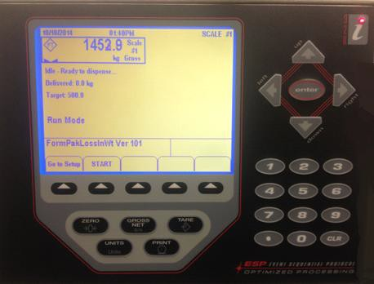
Go to Setup screen.
This will start the scale, but use the green button below.

This shows the weight on the BagPak 2100-SS that is ready for batching 1452.9 pounds, in this example.

III. Installation (Cont.)

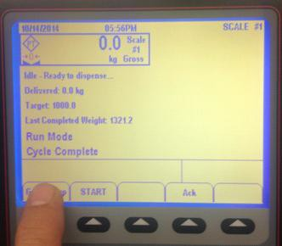
Programming of your BagPak-2100-SS Controller – Scale (Cont.)
Idle – Ready to Dispense. Pressing the green “START” button will start the scale. Note: the start button lights up when the scale is running.
Target weight: is the final weight of this batch.
Run Mode: The scale is ready to run a batch.
“Go to Setup” soft key will allow the operator to change the scale settings.

Delivered: is the amount of the current batch that is delivered
Press the “Setup” soft key to go to the setup screen.

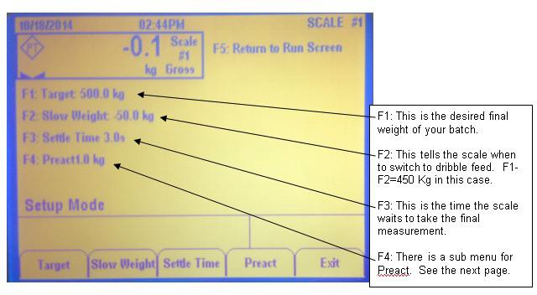

III. Installation (Cont.)

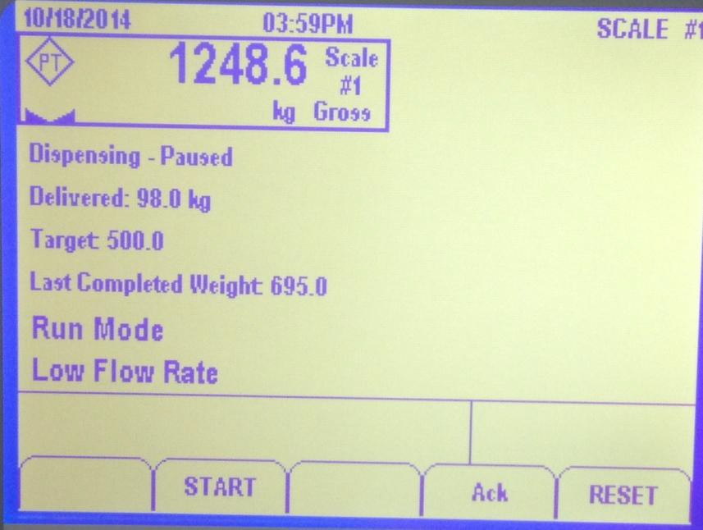
Programming of your BagPak-2100-SS Controller – Scale (Cont.)
Dispensing has paused, the screw is stopped.
98 Kg have been dispensed. Target weight is 500 Kg Press START to resume after
changing bag to continue with batch.

Press RESET to start a new batch.
Idle – Ready to Dispense. Pressing the green “START” button will start the scale. Note: the start button lights up when the scale is running.
Target weight: is the final weight of this batch.
Run Mode: The scale is ready to run a batch.
“Go to Setup” soft key will allow the operator to change the scale settings.

Delivered: is the amount of the current batch that is delivered

III. Installation (Cont.)

Programming of your BagPak-2100-SS Controller – Scale (Cont.)

The vibrator must not be running when the FILL weight is attained.
If the time for Weight 3 is too long, the bag could reach its FILL weight before the vibrator stops. AVOID THIS.

- In the Figure 21 example, the screen to change the weight that the first vibration cycle starts.
In this case the vibrator will turn on when the weight in the bulk bag has reached 500 lbs.
- To change this number, use the key pad to enter the new weight and then press the "NEXT" key to continue.
- In the next screen, the length of time the vibrator runs will show. The time is set at 10 seconds and the NEXT button is pressed (see Figure 22).
- Continue to enter the weights and times for the first three set points. TIME 4 is the vibration time after the final weight is attained.
- Once the vibration set points are entered, the FILL weight and TRIM must be set. FILL is the final weight desired in the bulk bag.
- Use the key pad to enter "8" then change the weight to the desired weight. 17. In the Figure 22 example, the final weight is set at 2000 lbs.
  - TRIM is the weight that the bulk bag is consistently over weight.
  - If your FILL weight is set at 2000 lbs, and the filled bags consistently weigh 2040 lbs, 40 lbs is the TRIM number.
  - Properly setting the TRIM will require some trial and error. d. Typically this takes no more than 3-4 cycles to determine.

IV. Operation

Operating your BagPak 2100-SS

1) Place a pallet on the base of the machine and center it under the fill head or between the horizontal support arms.

2) Feed the bulk bag lift loops (straps) onto the support arms so that the bag is centered above the pallet and under the fill head (or incoming material source). Note that the hanging height of the bag should be approx. 3” – 4” from corners of the bag to the top of the pallet. The bag is likely to touch the pallet in the center but, should have this 3" - 4" clearance and the corner of the bag.

3) If the bag has a spout, lift it up and around the inflation seal (rubber bladder).

4) While holding the bag spout up with one hand, use the other can flip the “Bag Seal” hand valve toggle switch. The bladder will fill with air and stop automatically at the correct pressure. Leave this bladder inflated during the entire filling cycle.

5) Once the inflation boot is inflated, the bag is sealed to the machine and is ready to fill. The screen below is the screen you will see first. The filling cycle is started by pressing the START soft key on the controller. Some control panels have a separate, green push button on the control panel. If you have that option, please use this push button. When it is pressed, the green light comes on, so you know the cycle has started.

6) The scale face will show the weight in the bag. The target weight, and the amount delivered.

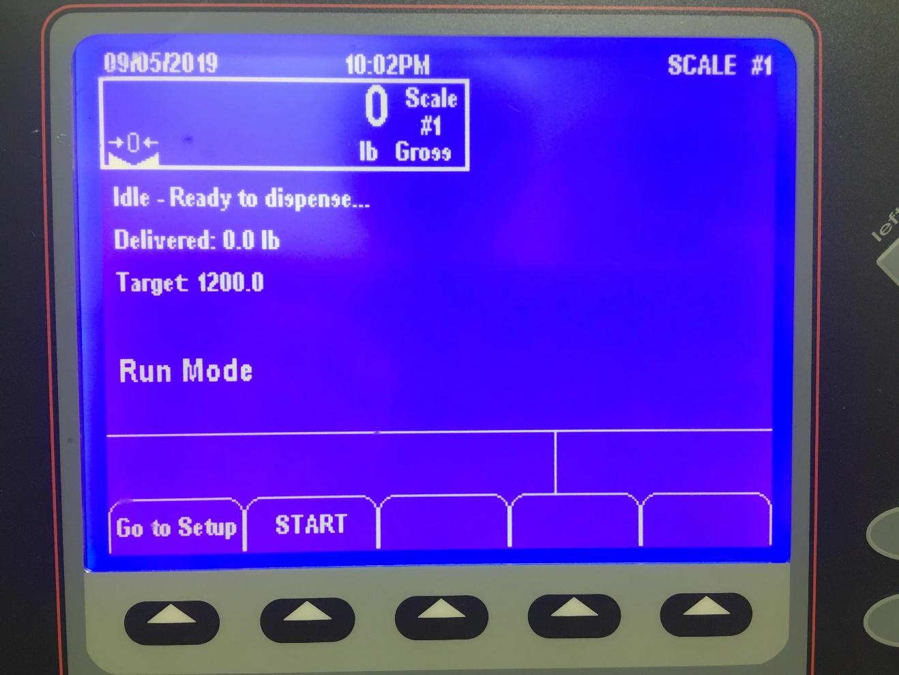
Actual weight in bag as it is being filled.
Target weight; This is the desired weight in bag.
The is the soft key to press to start the filling cycle.
IV. Operation
Operating your BagPak 2100-SS (Cont.)
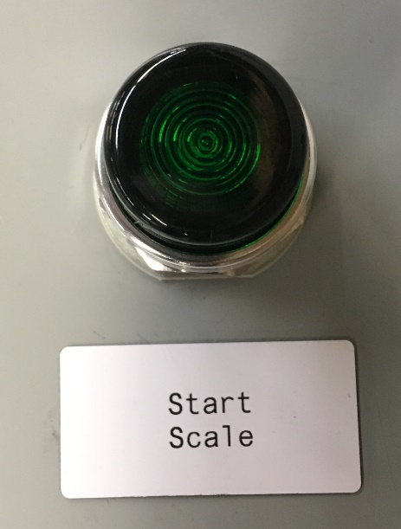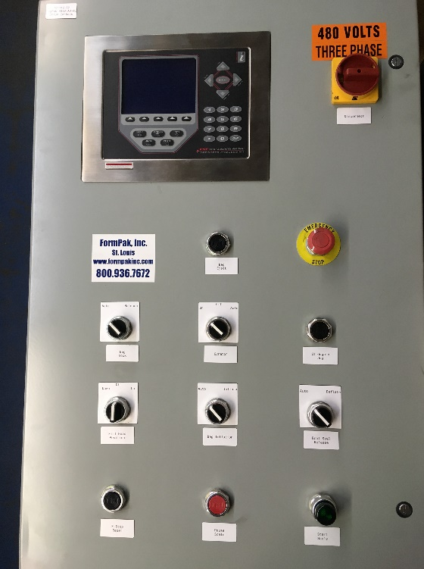
Start scale, external button. Lights up when pressed.

This is the screen you will see when the machine is running. It shows the weight in the bag (649 pounds), the target weight (1200), the last competed weight (1450.8), and the machine is in "Run Mode", which means material is being added to the bulk bag.
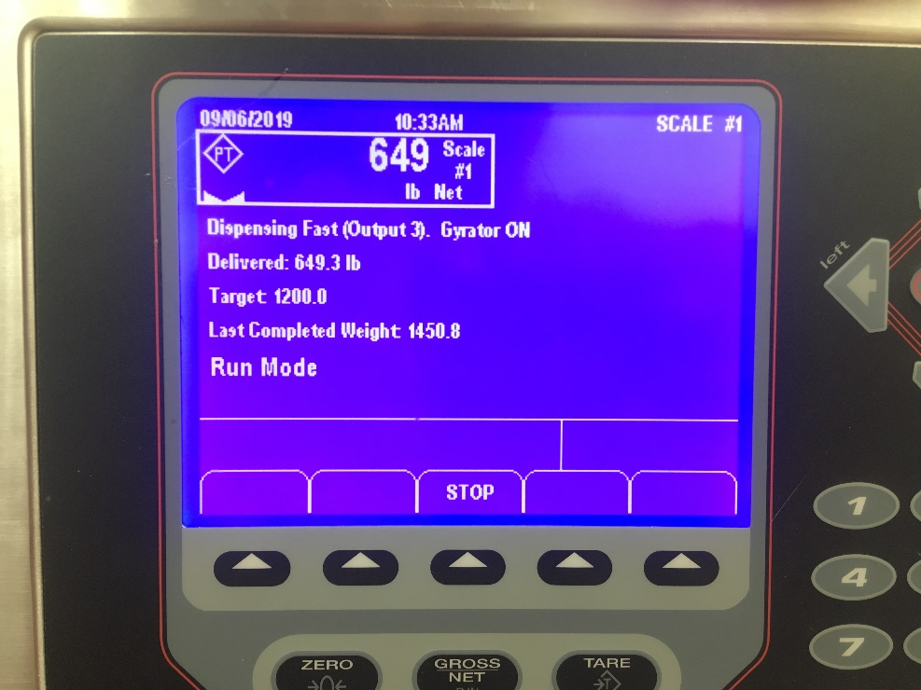
7) The scale controller monitors the flow of the material going into the bag. If this flow is too slow, the machine will pause the batch. The screen below is what you will see if this happens. In most cases, you'll want to get a supervisor to help figure out what is wrong.
IV. Operation
Operating your BagPak 2100-SS (Cont.)
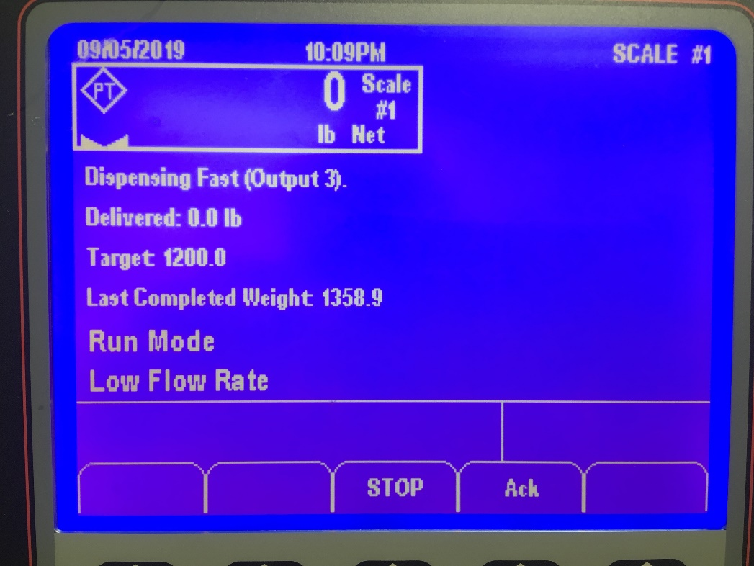
Low flow rate. The machine has determined the flow into the bag is too slow, and has paused the machine.
8) Situations may arise when the machine needs to be stopped. Pressing the "STOP" soft key will halt delivery of material to the bag. If you do press the STOP button, you’ll see it on the bottom left.

If you are able to easily 'fix' the problem, and you want to continue to fill the bulk bag, press the "START" button and the machine will continue filling the bag, to the correct Target weight. As soon as you press the START button to restart the machine, you will see the screen below. If you are able to easily 'fix' the problem, and you want to continue to fill the bulk bag, press the "START" button and the machine will continue filling the bag, to the correct Target weight. As soon as you press the START button to restart the machine, you will see the screen below.
Important things to note on this screen. The scale now shows zero pounds. This was reset by the STOP button, but the "Delivered:" line shows what is actually in the bag at the moment of restart, and this will continue to show the actual delivered amount of material in the bag.

If you are unable to easily fix the problem, and the bag needs to be removed and a new filling cycle started, you will see the screen below. Once the partially filled bag has been removed, you will see this screen.

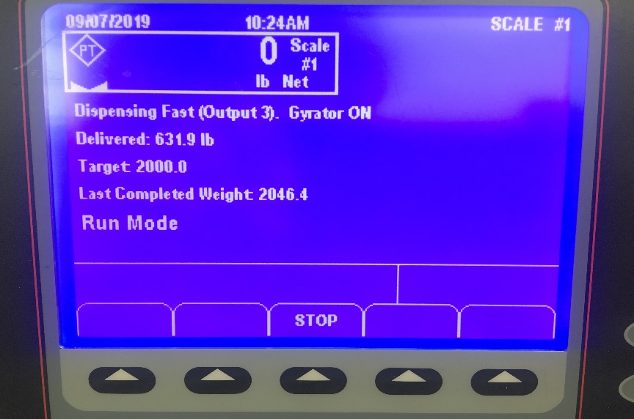

IV. Operation
Operating your BagPak 2100-SS (Cont.)

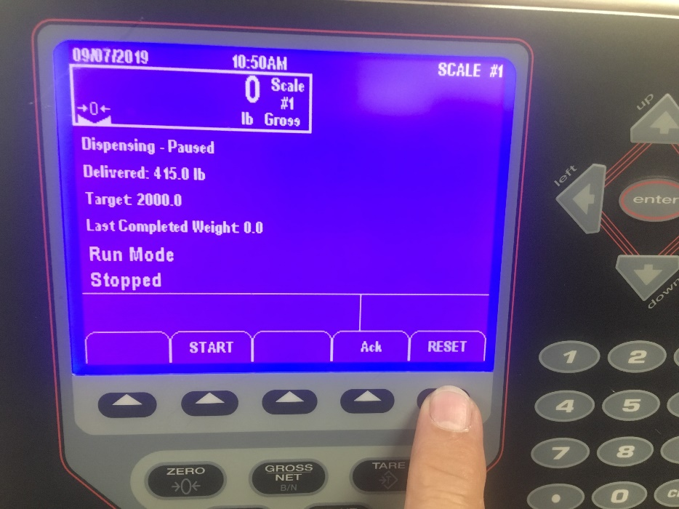
If you are unable to easily fix the problem, and the bag needs to be removed and a new filling cycle started, you will see the screen below. Once the partially filled bag has been removed, you will see this screen.

This screen shows that the aborted bag had 415 pounds in it, when the machine was stopped. To reset the machine, press the "RESET" soft key, then press the "Ack" soft key to return to the screen below, and continue to fill bags.

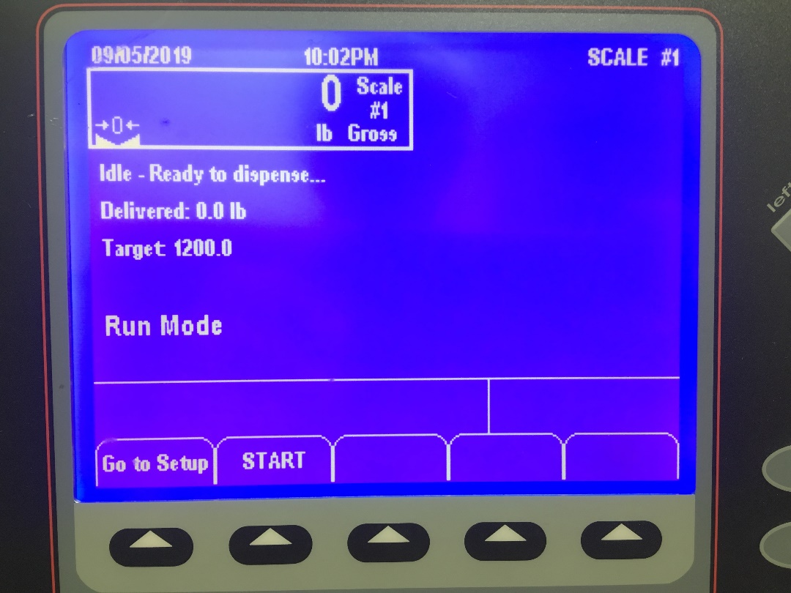
IV. Operation
Operating your BagPak 2100-SS (Cont.)

8) Once the bag is filled, you will see this screen.
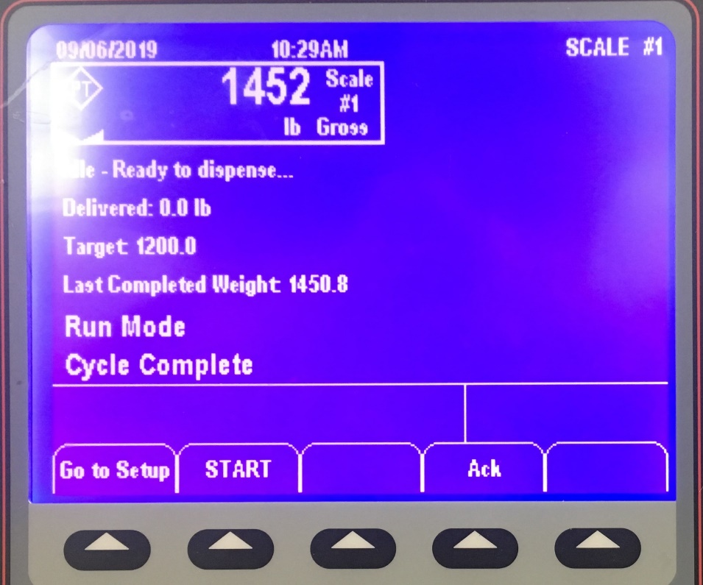
This indicates that the cycle is complete and the bag is filled.
9) Bag spout seal can now be flipped to the opposite (deflate) position. This removes the air from the bladder and allows the spout to be pulled down off the fill head. As soon as the boot deflates, pull the spout down, so it doesn't snag, when the fork lift removes the bag.

10) To remove bag, a forklift or pallet jack (requires low head or spread base for pallet jack access) will enter the pallet, lift up a few inches to remove the tension on the bag lift loops, and can then back out with the bag/pallet.

11) Bag spout must be tied closed. If it wasn't tied before it was removed, tie it closed now.

V. Maintenance
A weekly check of the framework, mounting bolts and hitch pins for proper installation, tightness and safety is recommended to keep the equipment in proper working order.

Fill Spout Seal (Expandable Bladder) Replacement

Fill head Replacement Video: https://youtu.be/BXy4NFepW8w

There is an upper clamp on this unit that is visible on the outer pipe of the fill head. This should be loosened first. Once loose, the bladder can be pulled out from under the clamp. The bladder should be pulled from the top edge down and inside out – exposing the second (inside) clamp. Once this clamp is loosened the bladder can be removed.

To replace, the bladder should be turned inside out (so that the slick side is out.) One end should be pulled up and onto the outer pipe of the fill head approximately 2” – 3”. A clamp should be pulled up and over the bladder and the fill head and tightened. The other end of the bladder should now be pulled up and over that clamped end (turning the bladder inside out). Once pulled slightly taught, the top clamp can be tightened over the top of the bladder. Unit is now ready for air hook up and inflation.

- Maintenance (Cont.)
Adjusting the air pressure on the Inflation Boot:

The air pressure on an inflation boot should not be adjusted higher than 5 psi. However, using the gage to set the pressure is not the best way.

To get the best life from the inflation boot, and reduce the chance of damaging a bulk bag fill spout, only inflate the boot enough to securely hold the bag on the machine spout. The best way to find that point is to open the regulator until the pressure in the line is zero. Pull the bulk bag spout up and over the inflation boot. Turn the hand valve to the inflate position, and begin to add pressure by turning the regulator knob. As soon as the fabric has stretched, completely, stop adding pressure. Tug firmly on the spout, to be sure it’s locked on, then proceed to fill the bags.

If the regulator pressure is set too high, the seam on the bag fill spout will start to rip. Turn the regulator pressure down, if you head the seam ripping.
Fill Head Booting:
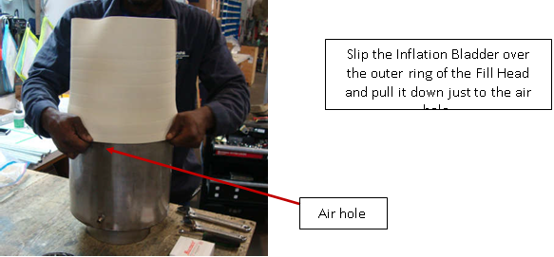
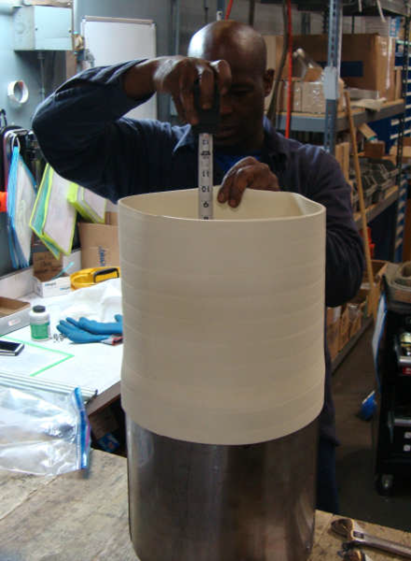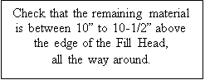
- Maintenance (Cont.)
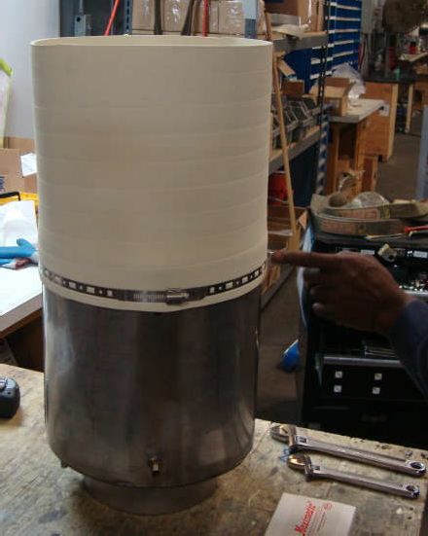
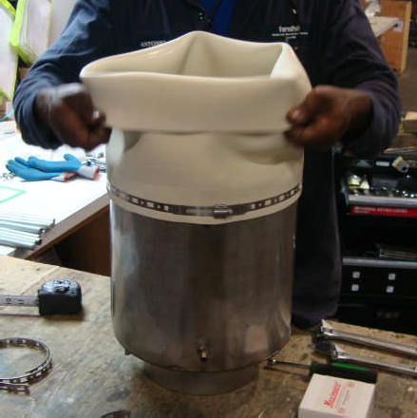
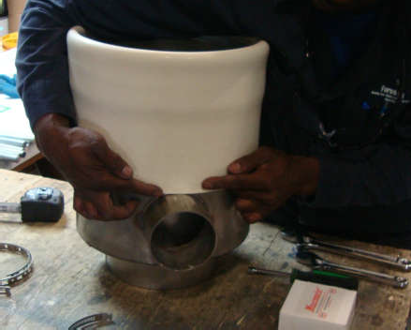
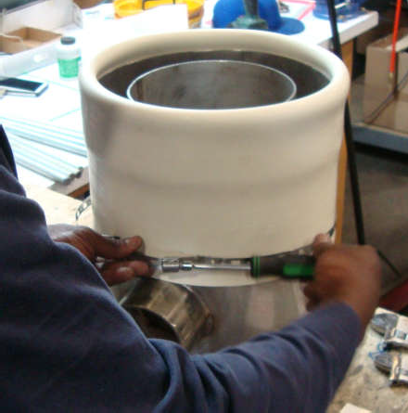
Fill Head Booting (Cont.)
Once the boot is in position, use and tighten the banding clamp
to secure the boot in place.
Tighten as hard as possible without breaking the clamp.
Next, fold over the boot to the outside and pull it down over the already clamped area.
Continue to pull the boot down onto the Fill Head until just at the dust port
Once the boot is in position, use and tighten the banding clamp
to secure the boot in place.
Tighten as hard as possible without breaking the clamp.
V. Maintenance (Cont.)
Gyrator Force Adjustment
Video Reference: https://www.youtube.com/watch?v=tkB0NYZSqp0&feature=emb_logo
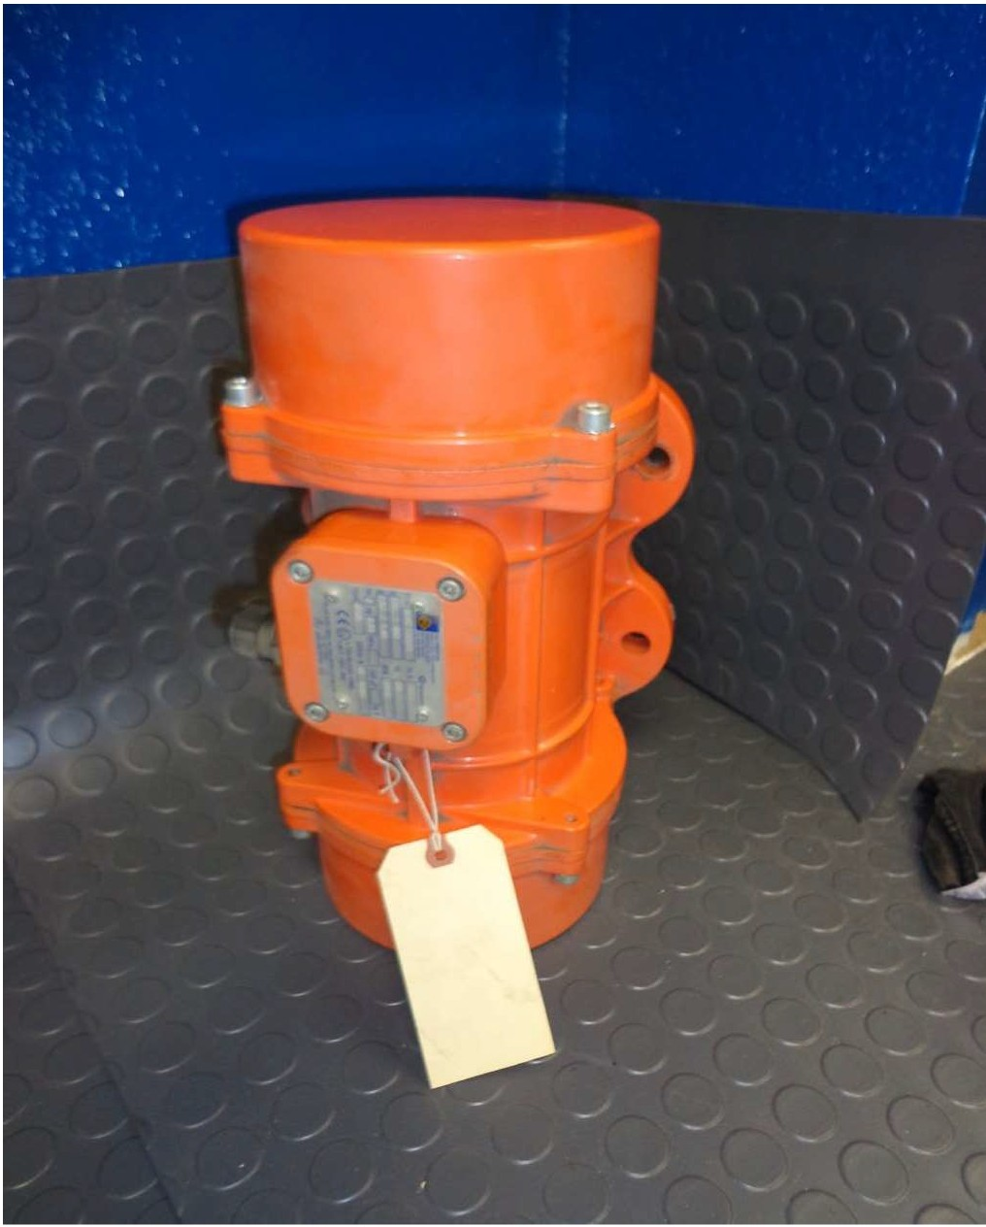
The pounds force provided by the Oli Gyrator is adjustable up to about 1500 lbs-force. To make these adjustments, the end caps must be removed from the gyrator.

Using the lowest setting that will let material flow or pack is always the best. Start with a low setting and adjust the force upward, until the desired flow or compaction is attained.

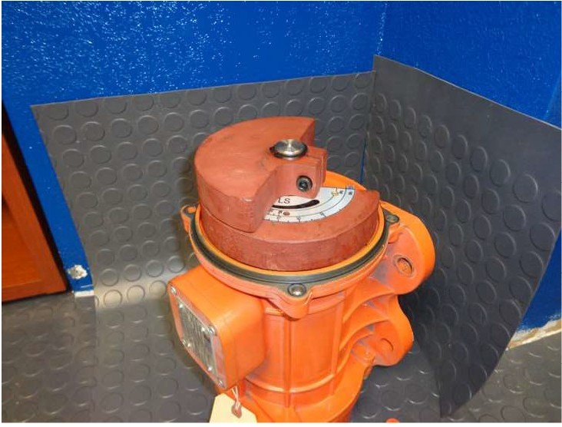
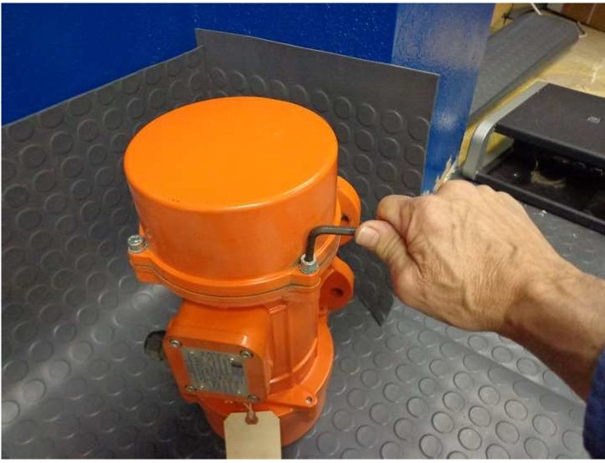
Remove the four cap screws from each end cap and remove the caps.

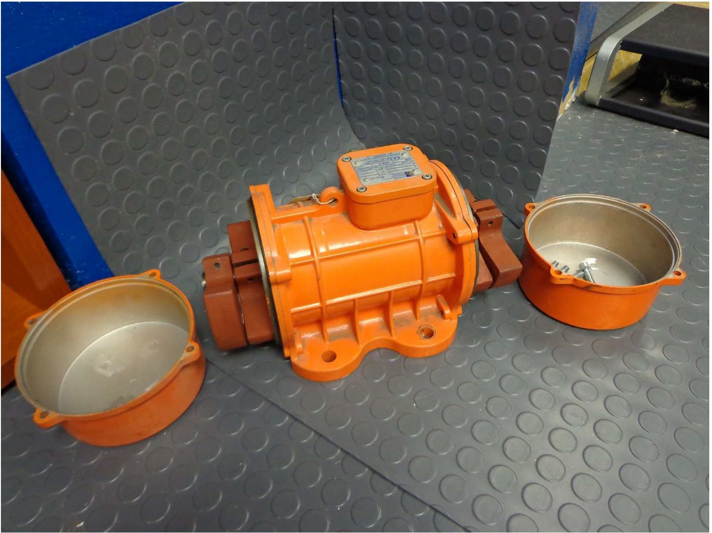
This is the Gyrator with both end caps removed.
Remember to adjust both ends to the exact same weight offset.

V. Maintenance (Cont.)
Gyrator Force Adjustment (Cont.)

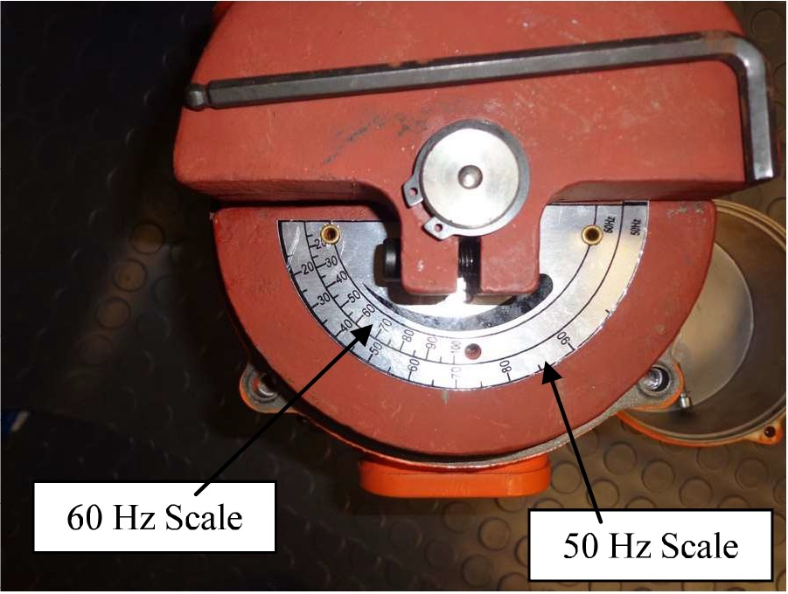
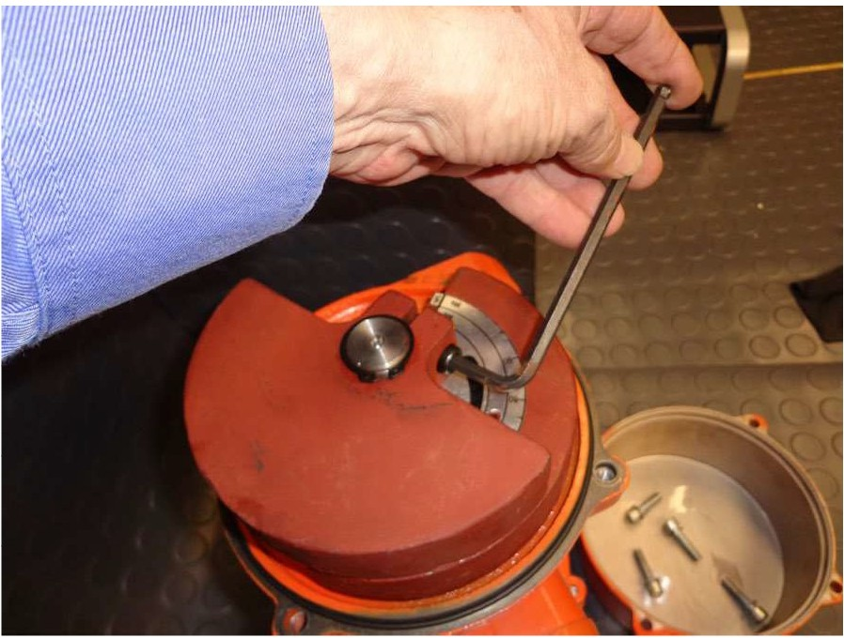
It is critical to adjust the weights on both ends of the gyrator to the exact same force. Failure to do so will cause premature failure of the bearings. Loosen the bolt that holds the counter weight in place, so the weight can be rotated to the correct position.
There are two force scales. One is for 60Hz the other is for 50Hz. Since the gyrator runs slightly slower at 50Hz, more off set weight is required to get the same pound force.
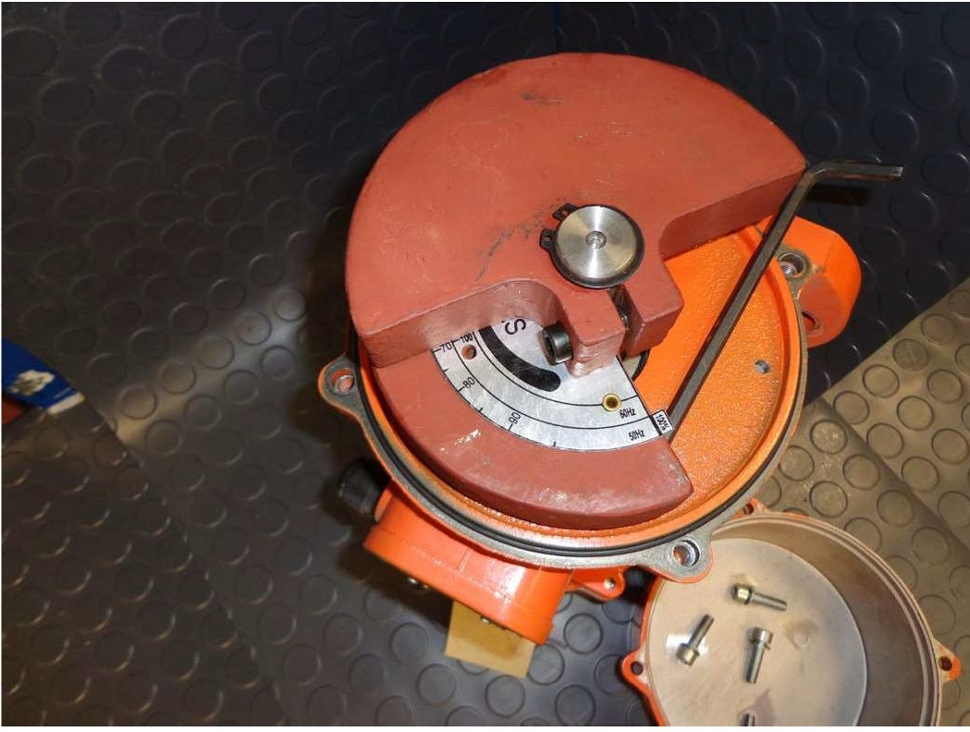
Be sure you are using the correct scale for the voltage frequency. USA customers will always use the 60Hz scale.
This is the position for 100% of the full force from this gyrator when running at 60Hz. Running the gyrator at a higher force setting than this, will cause premature bearing failure. It is recommended that Locktite or some other thread locking compound be used to secure these counterweight bolts. If one comes loose, it will most likely cause a bearing failure.
Once the weights on both ends are adjusted to the same pound force, replace the end caps.

VI. Replacement Parts List
* Not all of these parts below are on every unit *

- - Contact us for current pricing and lead time - -

ITEM: | PART NUMBER:
Inflation Bladder | 2312-u
Inflation Bladder Clamp | 4xz73
Air Inflation Assembly | FP-HVR-ASSY-002
Load Cell | SB-2500
Summing Box | JB4SS
Vibration Motor (Electric) | MVE.1530/4
Isolator | J-5425-1
Leveling Foot | RL-74582
Hitch Pin | 20133

VII. Optional Enhancements
Enhancement | Model |  | Reference | Overview
Load Cells | 2100-SS- IS |  |  | These are typically bolted into the frame and can be unbolted for removal. The scale wire associated with that load cell will need to be disconnected from the summing box. A new load cell can be bolted back into place, the nesting foot screwed back into place, and the control wire pulled back into the summing box and  connected to the requisite terminals.
Platform Scale | 2100-SS- PS | 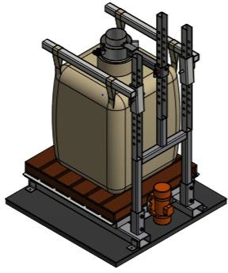 |  | A 5' x 5' or 4' x 5',  5,000# capacity floor scale with bag frame bolted to the top. Scale is pre- wired to a digital indicator.
Casters |  | 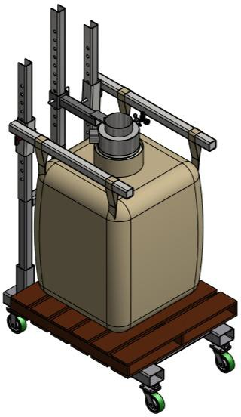 |  | For easy mobility  (4) casters can be added to the frame. These are typically arranged as (2) fixed and (2) swivel casters, all locking
VII. Optional Enhancements
Powered Indexing Arms |  | 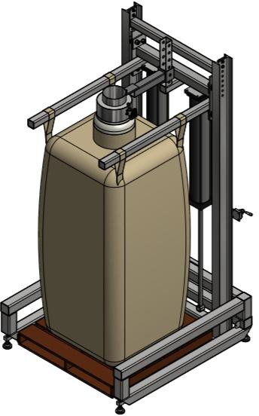 | Typically used when bags are very tall to facilitate easy attachment to filler, but can also be set up for a (2) bag size arrangement. Rear supports are I- beam construction and holder arm assembly is riding on bearings driven by air cylinders.
Densification Deck | 2100-SS- DD | 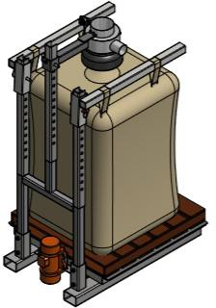 | By flex connecting a 48” x 48” diamond plate (reinforced) deck to (4) isolators and mounting a 1,500# force, 1HP dual shafted gyrator, the bag can be densified via high frequency vibration. This is typically done intermittently during fill cycle

VII. Optional Enhancements
Electrical Panel (to accompany densification deck) |  | 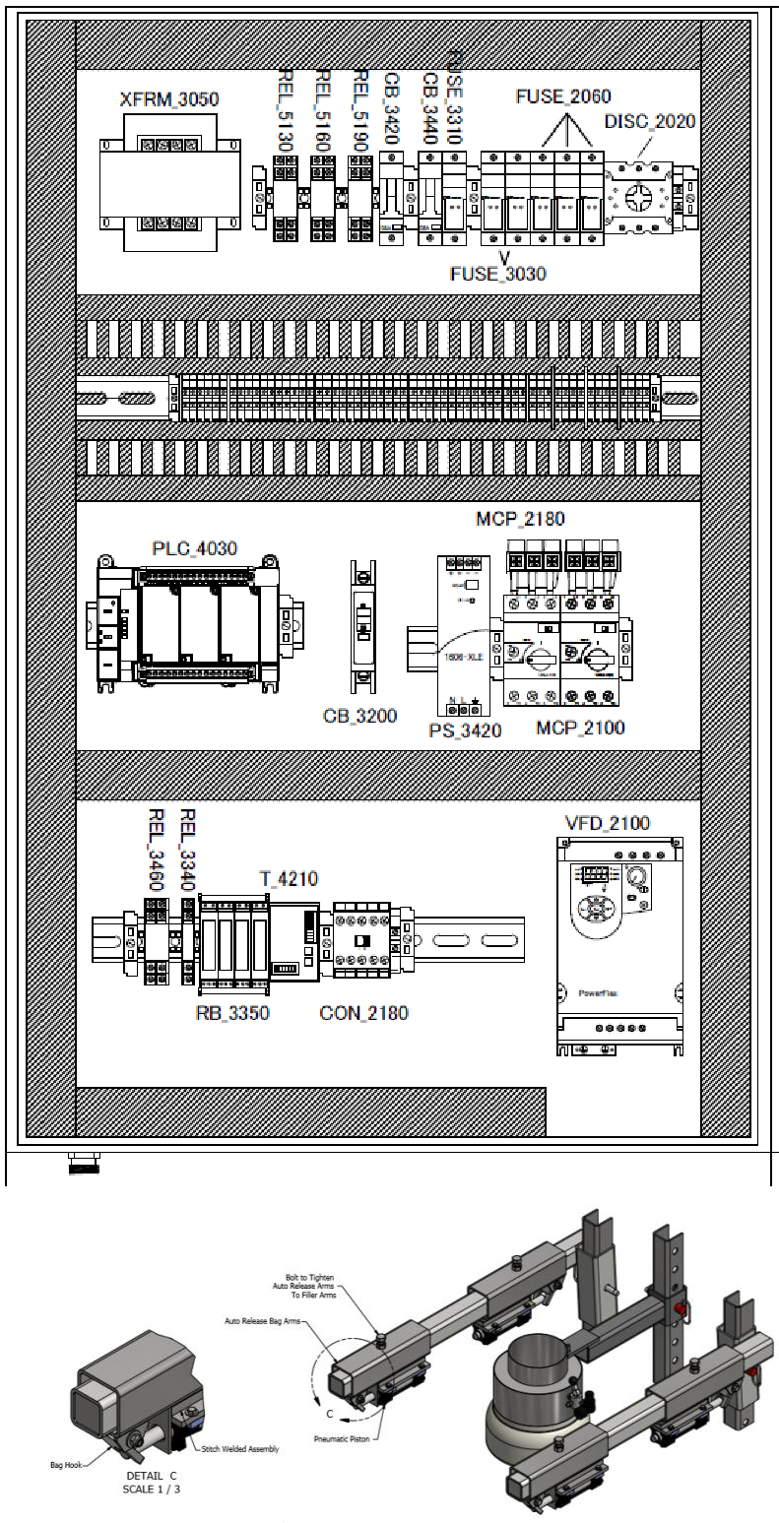
Autobag Release |  |  | This consists of (4) air-cylinders that the bag loops can be suspended from, once bag is full, these can be opened and the loops released.  This is helpful when bags will be removed from machine by lift loops vs. pallet, or if roller conveyors are added for bag  accumulation.
VII. Optional Enhancements
 | Grande (Extra Tall frame) |  |  |  | 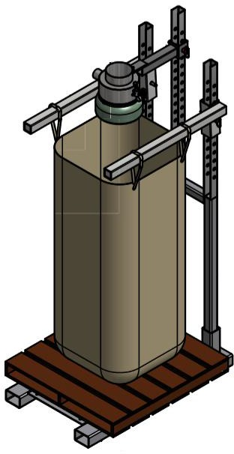
 | Hand Valve- Regulator- Gauge |  |  |  | 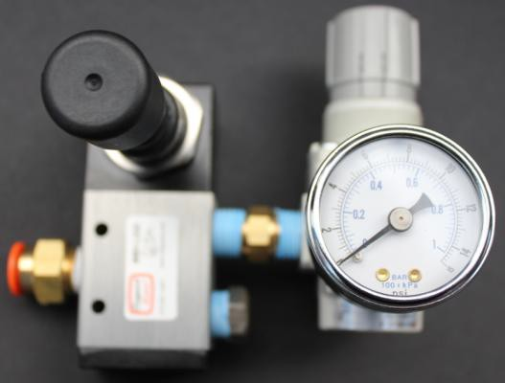 |  | This is simply a threaded piece, turn counter-clockwise to remove, clockwise to replace.
Mobile Base |  |  |  | 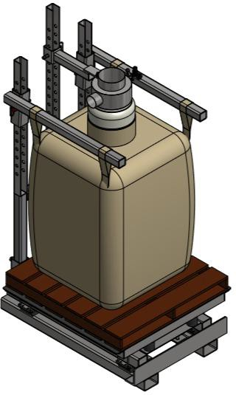
VIII. Formpak Machinery Catalog

BagPak Series (Bulk Bag Fillers)
- BagPak 1100-DT (Duffel Top Bag Filler)
- BagPak 2100-ST (Spout Top Bag Filler)
- BagPak 2100-SS (Spout Top, Scale Controlled Bag Filler)
- BagPak 4400-AD (Auto Discharge Bag Filler)

BagFlo/EasyFlo Series (Bulk Bag Dischargers)
- BagFlo 500-FL (Fork Loaded Bulk Bag Unloader)
- BagFlo 500-HT (Hoist & Trolley Loaded Bulk Bag Unloader)
- BagFlo 500-HF (Half Frame Bulk Bag Unloader)
- BagFlo 500-RK (Retrofit Kit)
- EasyFlo 500-FL (Free Flowing Bulk Bag Unloader)
- EasyFlo 500-HT (Free Flowing Bulk Bag Unloader)
- EasyFlo 500-HF
- BagFlo LIW (Loss-in-Weight Bulk Bag Unloader)
- BagFlo GC (Gantry Crane Bulk Bag Unloader)
- BagFlo SLH (Super Low Head)

Lifting Devices
- BagLift 100-CA (Bulk Bag Crane Adapter)
- BagLift 100-FA (Bulk Bag Fork Adapter)
- BagLift 100-FF (Flying Fork Adapter)
- BagLift 100-LH (Low Head)
- BagLift 200-HL (High Lift)

Small Bag Handling Equipment (Bag Break Stations)
- BagBreak 100-SH (Simple Bag Break Hopper)
- BagBreak 400-UC (Bag Break with Upper Cabinet)
- BagBreak 400-DF (Dual Filter Bag Break)

Other Products
- FlexFlo Flexible Screw Conveyors
- FeedFlo-VSF (Volumetric Screw Feeder)
- FeedFlo-VFV (Vibratory Volumetric Feeder)
- FeedFlo-SFS (Screw Feeder with Scale)
- FeedFlo-VFS (Vibratory Feeder with Scale
- FeedFlo LIW (Loss-In-Weight) feeder
- GH-1000 (Gyrated Hopper)
- VM-4000 (Venturi Mixing System)
- MatFlo (Lump Breaker)
- BagBreaker (Bag Conditioner)
- Live Hoppers
- Eduction Systems
- Batching Systems

